# Project Documentation Phase 8

Event Management & Ticketing System on Salesforce

## Phase 8: Data Management & Deployment – Event Management & Ticketing System

### 🔹 Objective

This phase ensures the *Event Management & Ticketing System* handles **data accuracy, backups, deduplication, and deployment** across environments. It combines Salesforce admin tools and developer practices to ensure the solution is stable, migration-ready, and enterprise-grade.

### 🔹 Key Components

Enter **Events manually** in Event tab.

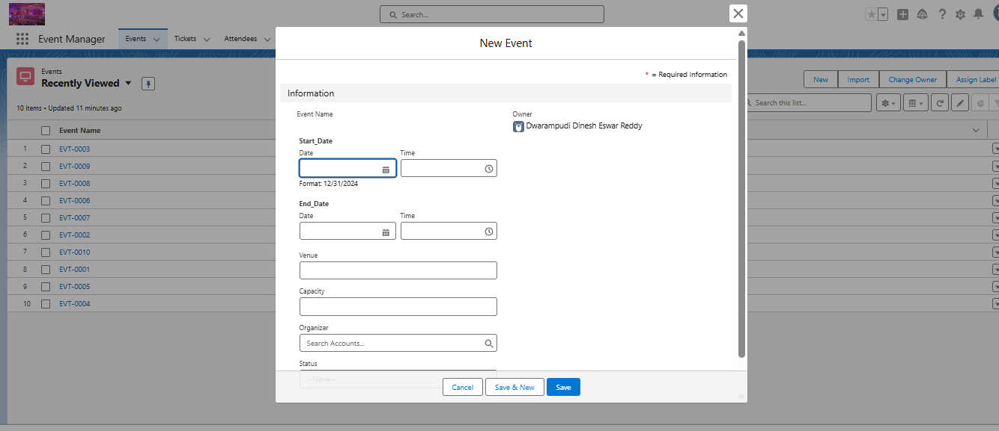

·

Enter **Events manually** in Attende tab.

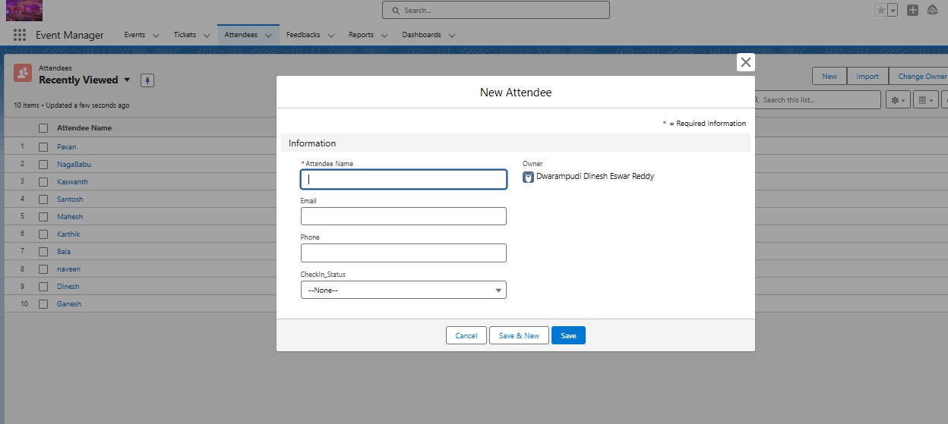

Enter **Events manually** in Tickets tab.

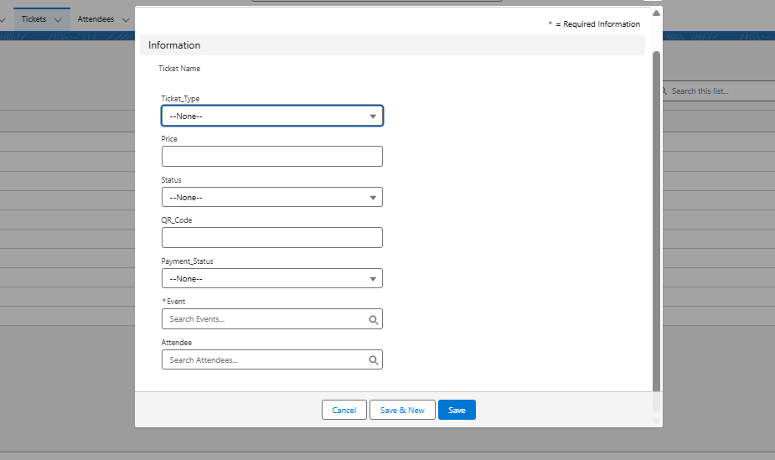

#### 

Enter **Events manually** in Feedback tab.

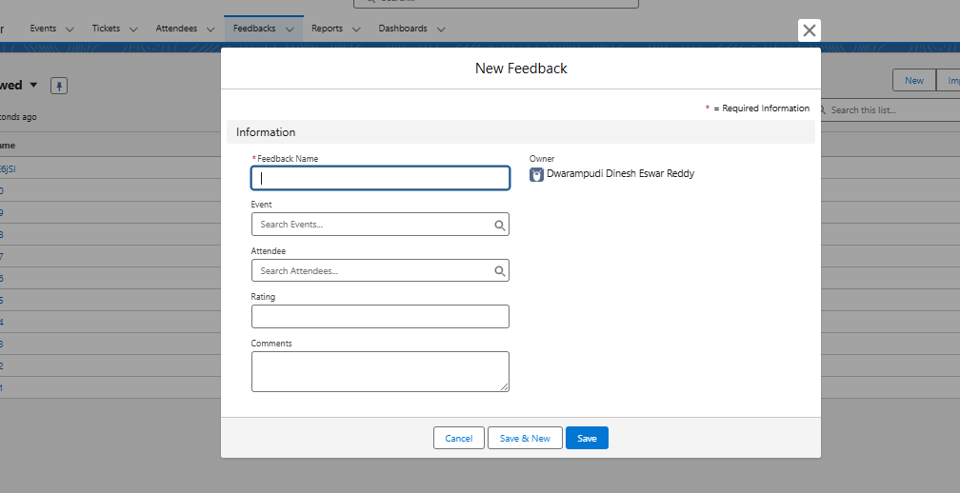

#### 1. Data Import Wizard

* Used for importing small to medium-sized datasets (up to 50,000 records).
* **Use Cases:**
  + Import Events, Attendees, and Tickets from CSV files.
  + Bulk upload initial event data for testing.
  + Example CSV fields for Attendee__c:
  + Name,Email__c,Phone__c,Event__c  
    John Doe,john@example.com,9876543210,EVT-001  
    Alice Smith,alice@example.com,9876500000,EVT-002

#### 2. Data Loader

* For large-volume data operations (up to 5 million records).
* **Use Cases:**
  + Bulk update ticket statuses (e.g., Issued → Checked-In).
  + Export attendee feedback for offline analysis.
  + Delete duplicate test data during QA.
* Supports **Insert, Update, Upsert, Delete, Export** operations.

#### 3. Duplicate Rules & Matching Rules

* Prevent duplicate attendee and ticket records.
* **Implementation:**
  + Matching Rule on Attendee__c → Match on Email__c + Phone__c.
  + Matching Rule on Ticket__c → Match on Event__c + Attendee__c.
  + Action → Alert user or Block record creation.

#### 4. Data Export & Backup

* Weekly scheduled data export for recovery.
* **Objects included:** Event__c, Ticket__c, Attendee__c, Feedback__c.
* Exports stored securely (local/cloud) for disaster recovery.

#### 5. Change Sets

* Migrates metadata (objects, fields, flows, triggers, LWCs) between environments.
* **Example:** Move tested automation from Sandbox → Production.

#### 6. Unmanaged vs Managed Packages

* **Unmanaged Package:** Used internally to share project components across dev orgs.
* **Managed Package (Future Scope):** For distributing the Event System as a reusable Salesforce app.

#### 7. ANT Migration Tool

* Enables scripted deployments for CI/CD.
* **Use Case:** Automating metadata migration for frequent updates.

#### 8. VS Code & Salesforce DX (SFDX)

* Development environment for Apex, LWCs, and metadata.
* **Steps Applied:**
  1. Connected Salesforce Org with sfdx force:auth:web:login.
  2. Pulled metadata into GitHub repo.
  3. Used scratch orgs for isolated testing.
  4. Deployed updates using sfdx force:source:deploy.

### 🔹 Outcome of Phase 8

✅ Clean and reliable event, ticket, and attendee data.  
✅ Automated backups ensure recovery.  
✅ Duplicate prevention improves data quality.  
✅ Deployment pipeline ready with Change Sets, ANT, and SFDX.

This completes **Phase 8 (Data Management & Deployment)** for the *Event Management & Ticketing System*. The system is now **data-driven, secure, and deployment-ready**.